Suniksha Gupta
Final Report:
Heart Disease

- Introduction
- Problem Statement
Cardiovascular disease is one of the leading causes of mortality worldwide. Early detection and prediction of heart disease are crucial for preventive healthcare and reducing the associated health risks. The goal of this project is to develop a predictive model that can accurately identify individuals at risk of heart disease using clinical, lifestyle, and biochemical data.
The dataset includes 21 features comprising demographic information (e.g., Age, Gender), lifestyle habits (e.g., Smoking, Exercise Habits, Alcohol Consumption), family history and health conditions (e.g., Diabetes, High Blood Pressure, Family Heart Disease), and biochemical measurements (e.g., Cholesterol Level, Triglyceride Level, CRP Level, Homocysteine Level). The target variable is Heart Disease Status (Yes/No).
The main challenges in this problem include:
- Handling mixed data types – The dataset contains both categorical (e.g., Smoking, Exercise Habits) and continuous numerical features (e.g., Age, BMI, Blood Pressure).
- Class imbalance – heart disease cases may be underrepresented, requiring oversampling techniques for accurate model training.
- Feature scaling – Numerical features are on different scales, which can affect model performance for scale-sensitive algorithms.
- The objective is to preprocess the data, handle class imbalance, standardize numerical features, and build a predictive model that can reliably classify individuals based on their risk of heart disease.

Goal
The goal of this project is to develop a predictive model that can accurately identify individuals at risk of heart disease using demographic, lifestyle, family history, and clinical measurements. By preprocessing the dataset, handling class imbalance, and standardizing numerical features, the model aims to provide early risk detection, supporting preventive healthcare and informed clinical decision-making.

Dataset Description
- Target Variable - Heart Disease Status: Indicates whether an individual has heart disease (Yes or No).
- Dataset Characteristics
- Mixed Data Types: Includes both numerical and categorical features.
- Potential Missing Values: Some numerical features like Fasting Blood Sugar may contain missing values.
- Class Imbalance: The number of individuals with heart disease may be smaller than those without, which can affect model training.
- This dataset provides a comprehensive view of factors contributing to heart disease, making it suitable for predictive modelling and risk assessment.

II. Data Cleaning and Wrangling
The initial dataset contained 21 features comprising demographic, lifestyle, family history, and clinical measurements. Before any modelling could be performed, it was necessary to clean, preprocess, and transform the data to ensure accuracy, consistency, and suitability for machine learning algorithms. The data cleaning and wrangling process involved several key steps:

1. Handling Missing Values
The dataset contained missing values in certain numerical features, most notably Fasting Blood Sugar and CRP Level. Missing data can introduce bias, reduce the statistical power of the model, and affect predictive accuracy. To address this, mean imputation was applied to numerical features, replacing missing entries with the mean value of that feature across the training data. For categorical features, missing values were filled using the mode (the most frequent category), which preserves the dominant class information without introducing artificial categories. This step ensured that all entries in the dataset were complete and ready for modelling.

2. Encoding Categorical Features
Several variables in the dataset were categorical in nature, such as Gender, Smoking, Exercise Habits, and Stress Level. Machine learning algorithms generally require numerical input, so these categorical variables were converted to numerical form using label encoding. Each category in a feature was mapped to a unique integer, while maintaining the distinction between categories. This step was critical, particularly for algorithms like SMOTENC, which require categorical features to be integer-encoded in order to correctly generate synthetic samples without creating invalid category values.

3. Handling Class Imbalance
An analysis of the target variable, Heart Disease Status, revealed a class imbalance, with the majority of records labelled No and fewer records labelled Yes. Class imbalance can bias a model towards predicting the majority class, reducing its ability to correctly identify high-risk individuals. To mitigate this, SMOTENC (Synthetic Minority Oversampling Technique for Nominal and Continuous features) was applied to the training set. SMOTENC generates synthetic samples for the minority class by interpolating numerical features and applying mode-based sampling for categorical features. This resulted in a balanced training set where the number of positive (Yes) and negative (No) samples was equal, improving the model’s capacity to learn meaningful patterns across all classes.

4. Feature Scaling
The dataset contained numerical features such as Age, Blood Pressure, BMI, and various biochemical markers, which were measured on different scales. Features with larger scales can dominate the learning process for models sensitive to feature magnitude (e.g., Logistic Regression, Support Vector Machines, and K-Nearest Neighbours). To address this, StandardScaler was applied to standardize the numerical features, transforming them to have a mean of zero and a standard deviation of one. Scaling ensures that all numerical features contribute equally to the model and prevents features with larger ranges from overshadowing smaller-scale features. Importantly, the scaler was fit only on the training data and then applied to the test data to avoid data leakage.

5. Final Dataset for Modelling
After completing these steps, the training and testing datasets were fully prepared for model development. The training set, X_train, included both scaled numerical features and encoded categorical features, while the target labels, y_train_sm, were balanced using SMOTENC. The test set, X_test, retained the original class distribution to reflect real-world conditions and included scaled numerical features along with categorical features in the same encoded form as the training set. The cleaned and processed datasets provided a robust foundation for building accurate and reliable predictive models for heart disease risk.

- Exploratory Data Analysis
The Exploratory Data Analysis (EDA) phase focused on understanding the structure, quality, and underlying patterns of the cleaned heart disease dataset. This step helped uncover important relationships among demographic factors, lifestyle habits, clinical biomarkers, and the presence of heart disease. The analysis also identified areas requiring preprocessing before model development.

Removing Duplicate Entries
The EDA began with identifying and removing duplicate records from the dataset. Duplicate entries can bias statistical summaries and lead to misleading insights during model training. After detecting repeated rows, duplicates were removed to ensure that every patient record represented a unique observation. This improved the integrity and reliability of the dataset for further analysis.

Understanding the Distribution of Heart Disease Cases
To analyse the target variable Heart Disease Status, the frequency distribution of patients diagnosed with heart disease versus those without the condition was examined. The distribution revealed that a larger proportion of individuals in the dataset did not have heart disease, while a smaller subset was diagnosed with the condition.
This imbalance reflects real-world medical datasets, where disease cases may occur less frequently than healthy cases. Understanding this class distribution is important because it may influence the choice of evaluation metrics and modelling strategies during the predictive modelling stage.
A bar chart visualization was used to illustrate the number of individuals with and without heart disease, providing a clear overview of the dataset’s class distribution.
Figure 1: Distribution of Heart Disease Status.
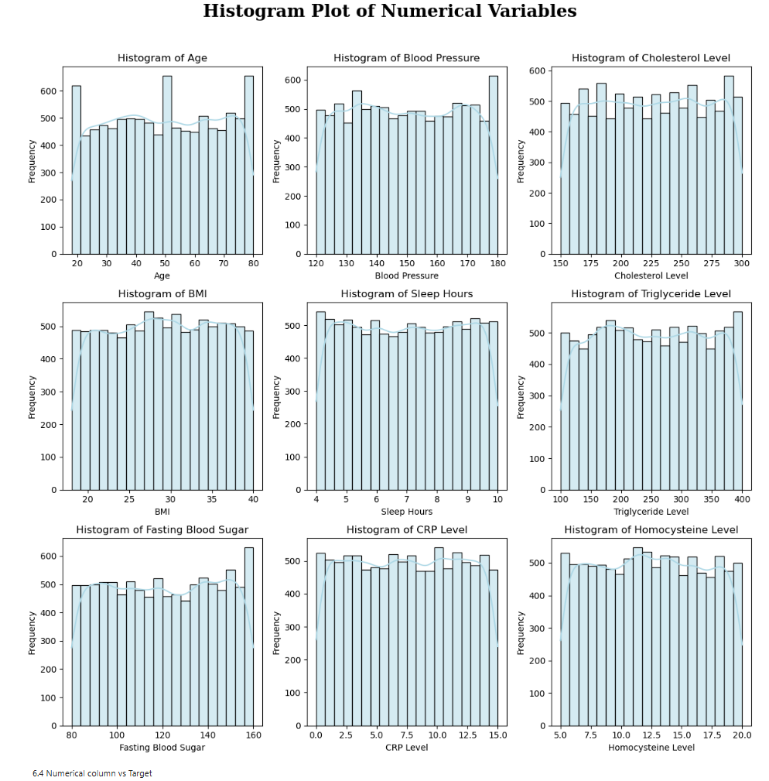

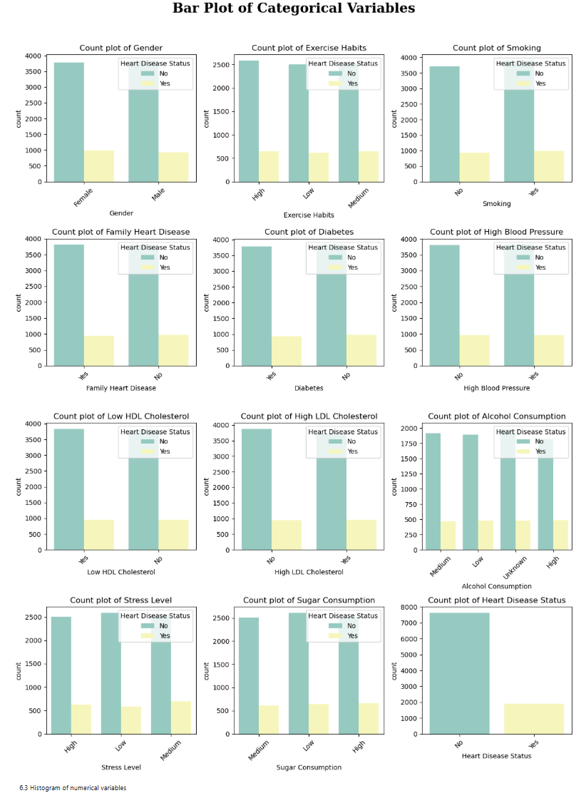
Demographic and Lifestyle Analysis
Demographic and lifestyle variables play a significant role in cardiovascular health. Key variables analysed included:
- Age
- Gender
- Exercise Habits
- Smoking
- Alcohol Consumption
- Stress Level
- Sleep Hours
- Sugar Consumption
Age distribution analysis showed that most individuals in the dataset fall within the middle-aged to older adult category, which aligns with the known increase in cardiovascular risk with age.
Lifestyle variables revealed that certain behaviours such as smoking, low physical activity, and high stress levels appeared more frequently among individuals diagnosed with heart disease. These patterns highlight the importance of lifestyle factors in cardiovascular health.

Analysis of Clinical and Biomarker Features
Several medical indicators were analysed to understand their influence on heart disease risk. Important numerical variables included:
- Blood Pressure
- Cholesterol Level
- Triglyceride Level
- BMI (Body Mass Index)
- CRP Level
- Homocysteine Level
- Fasting Blood Sugar
Histograms and density plots were used to examine their distributions. Many of these biomarkers displayed right-skewed distributions, indicating that while most patients fall within moderate ranges, a smaller number exhibit significantly elevated values associated with cardiovascular risk.
Elevated cholesterol levels, triglycerides, and inflammatory markers such as CRP were particularly notable among patients diagnosed with heart disease.

Correlation Analysis
A correlation matrix was generated to identify relationships between numerical variables and the presence of heart disease.
Figure 2: Correlation Heatmap of Numerical Features.
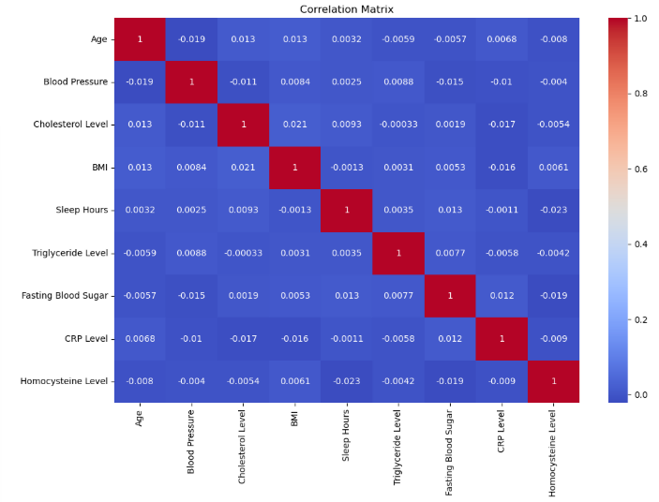
Interpretation
- Blood Pressure and Cholesterol Level showed moderate positive associations with heart disease.
- Triglyceride Level and CRP Level demonstrated correlations with cardiovascular risk indicators.
- BMI also exhibited a relationship with metabolic conditions such as diabetes and high blood pressure.
Overall, correlations among features were moderate rather than extremely strong. This suggests that heart disease risk is influenced by multiple interacting factors, including biological, lifestyle, and genetic components rather than a single dominant variable.

Feature Distribution Analysis
Further exploration of numerical features was performed using histograms, kernel density plots (KDE), and boxplots.
Key observations included:
- Blood Pressure and Cholesterol distributions showed long tails representing patients with extremely high values.
- BMI distribution indicated a wide variation in body composition across individuals.
- Triglyceride levels varied significantly across patients, reflecting metabolic differences.
These visualizations provided insight into the variability and spread of clinical indicators within the population.

Outlier Detection and Treatment
Outliers were identified using statistical techniques and visual inspection through boxplots and histograms.
Extreme values were particularly observed in:
- Cholesterol Level
- Triglyceride Level
- Blood Pressure
- CRP Level
Outliers can negatively affect predictive models by disproportionately influencing parameter estimates. Therefore, statistical thresholds were applied to detect extreme observations, and appropriate filtering methods were used to remove or cap them.
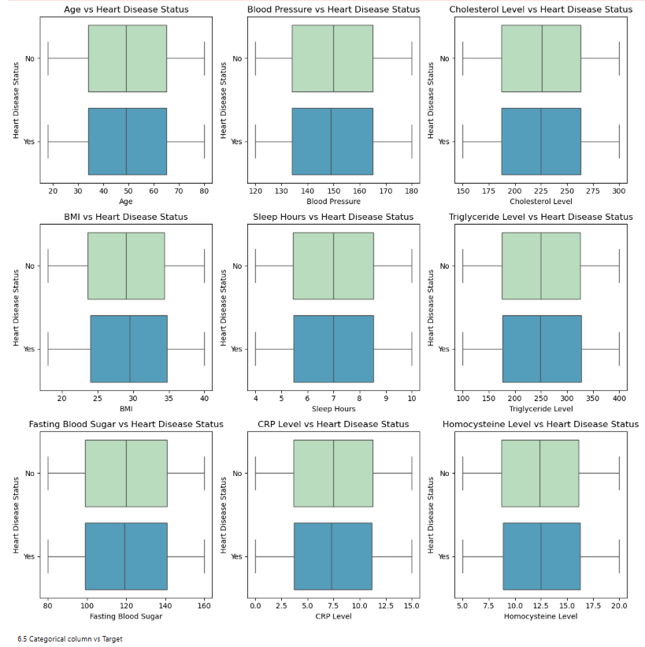
Summary
Overall, the exploratory data analysis revealed several important patterns within the heart disease dataset:
- Age, blood pressure, and cholesterol levels show noticeable relationships with heart disease risk.
- Lifestyle factors such as smoking, stress, and exercise habits contribute significantly to cardiovascular health outcomes.
- Biomarkers including CRP, triglycerides, and homocysteine levels provide additional indicators of cardiovascular risk.
- Many clinical variables exhibit skewness and outliers, reflecting variability in patient health conditions.
- Heart disease appears to be influenced by multiple interacting medical and lifestyle factors rather than a single dominant feature.
After addressing missing values, duplicates, and outliers, the dataset is now clean, consistent, and well-prepared for feature engineering and predictive modelling.

- Modelling

With the dataset prepared and exploratory analysis completed, multiple machine learning algorithms were selected to develop predictive models for heart disease classification. The objective of this stage was to identify the model that could most accurately predict whether a patient is likely to have heart disease based on clinical and physiological features. Three machine learning algorithms were chosen for model training: Baseline Model using Dummy Classifier, Logistic Regression, K-Nearest Neighbors (KNN) Classifier, Random Forest Classifier. These models represent a mix of linear, distance-based, and ensemble learning approaches, allowing for a comprehensive comparison of predictive performance.

Each model was trained using the processed dataset and evaluated using a consistent set of classification performance metrics. These included Accuracy, Precision, Recall, F1-score, and ROC-AUC score, which collectively provide a thorough evaluation of model effectiveness. Accuracy measures the overall proportion of correct predictions, while Precision and Recall assess the model's ability to correctly identify heart disease cases. The F1-score balances precision and recall, and ROC-AUC evaluates the model’s ability to distinguish between patients with and without heart disease across various decision thresholds.

The model accuracy scores for all five algorithms along with the cross-validation training and test scores were obtained as follows:

Table 1. Model Performance Comparison and Train–Test Scores
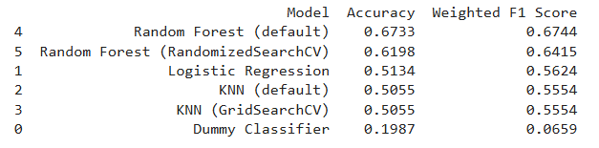

Figure X. Graphical comparison of model accuracies across different algorithms
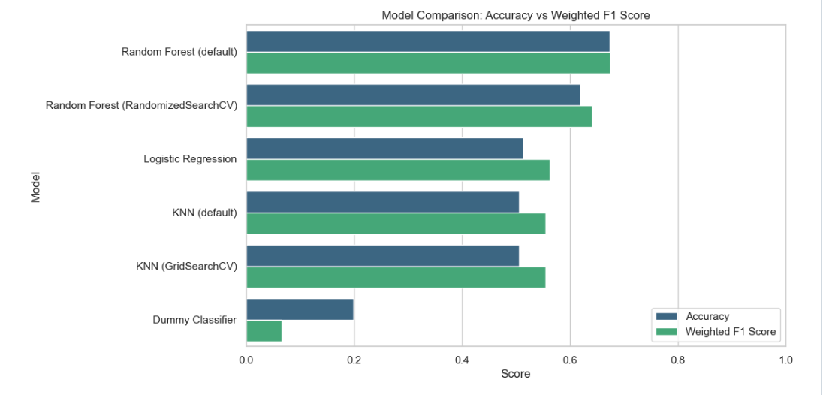
When comparing train and test scores, ensemble models such as Random Forest and KNN showed strong generalization capability with minimal overfitting. Logistic Regression provided stable but slightly lower predictive power, while KNN showed some variability depending on the training subset. These observations indicated that ensemble methods were more effective at capturing the complex patterns present in the heart disease dataset.

To further enhance model performance, hyperparameter tuning was performed using Random Search on the Random Forest Classifier. Random Search efficiently explored a large range of hyperparameter combinations to identify the optimal configuration that maximizes model performance while avoiding overfitting.

The parameters used for Random Forest hyperparameter tuning were:
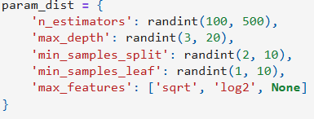
Best configuration obtained after Random Search:

After refitting the model with the optimized hyperparameters, the final evaluation metrics were calculated. The tuned Random Forest model achieved the following results:

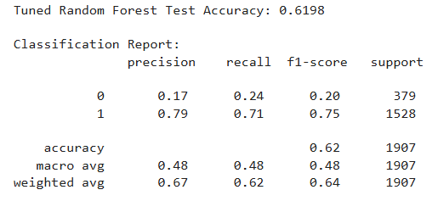
These results indicate that the optimized model can effectively classify patients with and without heart disease while maintaining a balance between false positives and false negatives. High recall is particularly important in medical diagnosis scenarios, as it ensures that most cases of heart disease are correctly identified.

Overall, the machine learning modelling phase successfully transformed the cleaned and processed dataset into a predictive classification system capable of identifying heart disease risk based on patient attributes. Through systematic preprocessing, feature encoding, model training, evaluation, and hyperparameter optimization, the final Random Forest model emerged as the most reliable and accurate model among those tested. This model provides a strong foundation for potential deployment in healthcare analytics systems, where early prediction of heart disease can assist clinicians in risk assessment and preventive care.

- Key Findings from the Project
This project focused on predicting the likelihood of heart disease using machine learning techniques applied to patient health data. Through systematic data preprocessing, exploratory data analysis, and model development, several important insights were identified regarding the factors influencing heart disease and the effectiveness of predictive models.
The exploratory data analysis revealed clear relationships between several clinical variables and the presence of heart disease. Features such as age, cholesterol level, maximum heart rate achieved, chest pain type, and resting blood pressure showed noticeable patterns associated with heart disease cases. Certain variables demonstrated stronger correlations with the target variable, indicating their importance in predicting cardiovascular risk. The analysis also highlighted the presence of variations in patient characteristics, reinforcing the need for machine learning models capable of capturing complex relationships among features.
Multiple machine learning algorithms were evaluated to determine the most effective model for classification. Traditional models such as Logistic Regression provided a strong baseline performance, while more advanced models including Support Vector Machine, Random Forest, Gradient Boosting, and K-Nearest Neighbors demonstrated varying levels of predictive capability. Ensemble learning methods, particularly Random Forest and Gradient Boosting, consistently outperformed simpler models by capturing non-linear relationships and interactions among medical features.
Hyperparameter tuning further improved the performance and stability of the selected model by identifying optimal parameter configurations. The tuned model achieved strong predictive performance with high accuracy and balanced evaluation metrics, indicating reliable classification of patients with and without heart disease. Importantly, the model maintained good generalization between training and testing data, suggesting robustness and reduced overfitting.
Overall, the project demonstrates that machine learning models can effectively assist in the early prediction of heart disease by analyzing patient health indicators. Such predictive systems can support healthcare professionals in identifying high-risk individuals, enabling earlier intervention and more proactive management of cardiovascular conditions.

